2023 - 2024 Executive Board Nominees

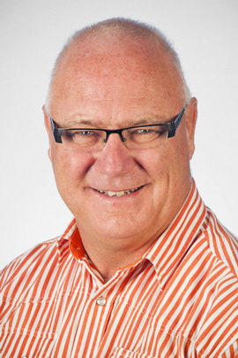
STEPHEN GREY – current CHAIRMAN – (existing)
Chester Grey Accountants Ltd
Stephen is a Chartered Accountant and Director of Chester Grey Chartered Accountants Ltd, Manukau. He has been advising a large range of businesses for over 40 years. He has served the Manukau District as a Local Body Politician for 27 years and is an Independent Director of companies servicing the Engineering, Education, Financial Services and Media sectors.
He has lived in Papatoetoe all his life.

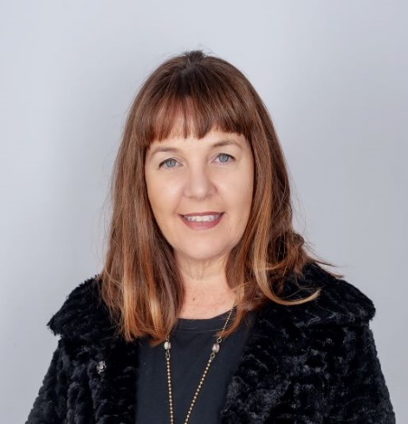
BELINDA SUTTON – current TREASURER - (EXISTING)

Van Den Brink Group
Belinda is the Property Manager for the Van Den Brink Group and takes an active part in the Manukau Business District through her management of Southpoint on the corner of Cavendish Drive and Great South Road. The Southpoint complex includes the anchor tenant Countdown, Westpac, Urban Soul and a variety of other food and commercial business establishments. Belinda’s background was in the apparel industry. She has been in the property sector for 11 years. In her spare time Belinda spends time with her family and enjoys boating, fishing and skiing.

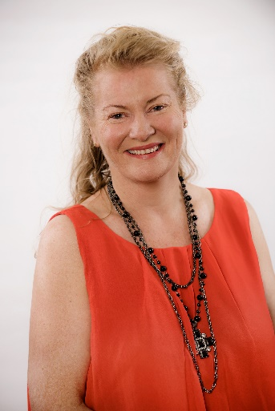
RACHEL DARLINGTON (existinG)

Business Like (NZ) Ltd
Rachel is a Chartered Accountant (CA) and a member of Chartered Accountants Australia and New Zealand. She also holds a current certificate of public practice. Rachel completed a Bachelor of Commerce degree at Auckland University and post graduate diploma in Professional Accounting at Manukau Institute of Technology. She began her accountancy career in the corporate arena whilst working for a merchant banking firm for ten years. Since then, Rachel has worked as a chartered accountant and business advisor specializing in small to medium sized businesses. Business Like NZ Limited is a forward focused chartered accountancy practice that has been serving local Manukau businesses for many years.

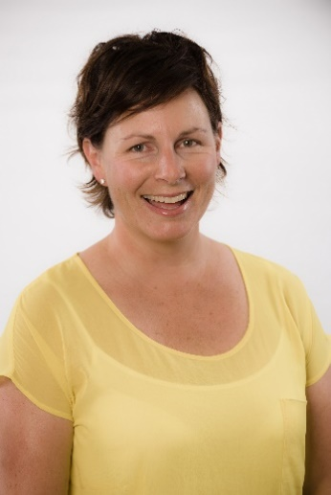
EMILY MAY (existing)

Jaedon Enterprises
Emily May is the Managing Director at Jaedon Enterprises Ltd, a New Zealand based clothing manufacturer, specializing in technical garments, servicing the needs of high-risk industries and emergency response teams. Jaedon is a family-owned business that was established 25 years ago by Emily’s father. Jaedon has an established local and international client base and dominates the market for high-specification industrial apparel, providing innovative design solutions, customer service, and an understanding of local and international compliance requirements. Emily champions New Zealand-made, and local innovation. She is interested in engaging younger generations in manufacturing within NZ, particularly in the apparel sector.

DEBRA LAW (EXISTING)

Law and Associates
Debra is the principal of Law & Associates, which is an established general legal practice with an emphasis on property, commercial, trusts, family, estates and dispute resolution. As principal of Law & Associates, and before that a partner of Wood Ruck Manukau, Debra has been practising in Manukau for more than 23 years. Debra is results driven and enjoys working alongside clients to achieve sound commercial outcomes. In her spare time Debra breeds sport horses on her lifestyle property in Karaka.

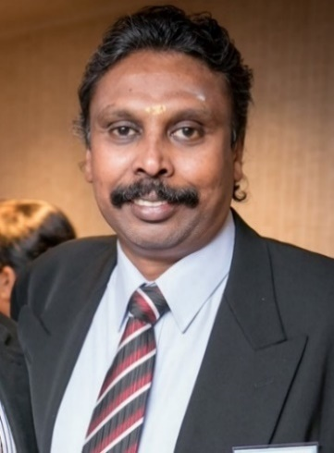
ILANGO KRISHNAMOORTHY (existing)
Mercury Printz / IRIS Signs Limited
Ilango is the Director of Mercury Printz and Iris Signs. Whilst Mercury Printz focuses on offset and digital printing, Iris Signs offers signage solutions to its clients. Ilango is a Qualified Automobile Engineer from India. He has an MBA Qualification from Waikato University, is very active in the Indian Community, and is one of the founding members of NZ Hindu Temple Society Inc. He is also a trustee for “South Asian Trust Inc.” which provides counselling services to the community through its service arm “Sahaayta Auckland”. He is a keen businessman and an active member of voluntary societies, and community and political organisations. Ilango is married to Sakthi, a lawyer at Avondale Law and between them they have three children.

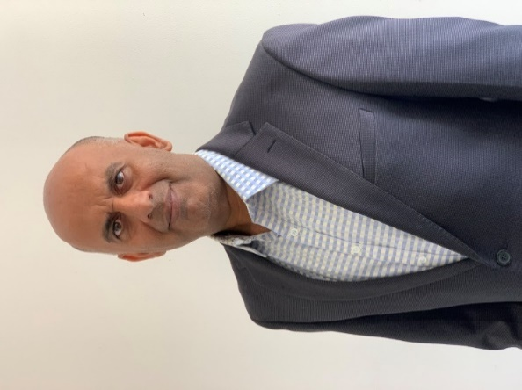
SOHAIL CHAUDHRY (existing)
The Computer Warehouse
Sohail has owned The Computer Warehouse for 17 years. He also owns another business in Manukau and two commercial properties. He has good connections with local businesses and has been involved in a number of other Associations, namely the South Asian Advisory Board for Counties Manukau Police for the last 6 years; the South Auckland Muslim Association; the Executive Board of Pakistan Association (Community Trust) of New Zealand. Sohail is a keen outdoor enthusiast and hiker who has walked some of the NZ Great Walks.

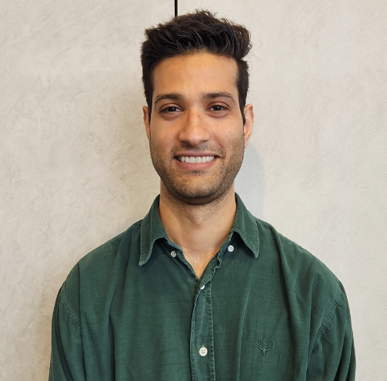
AARI puri (new)
Brew’d Hawt
Aari is an Entrepreneur and Restaurateur, currently Director of Brew’d Hawt restaurants. He has opened and owned multiple restaurants in the past. He is a qualified chef and has 14 years of diverse experience within the industry, from overlooking operations of multiple restaurants, hotels and cinemas. He also does consulting work and has experience in scaling businesses and building national supply chains. He is passionate about hospitality, customer experience, building engaging communities, and collaborating with like-minded people and local business.

