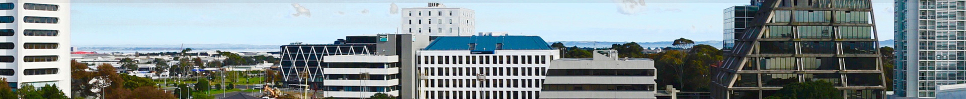
Business Manukau Associate Membership
Thank you for considering joining the Manukau Business Association Inc. (Business Manukau) as an Associate Member.
Business Manukau (BM) is the Heart of the South, vibrant, diverse, and a fast-growing suburb in South Auckland.
Our Associate membership will provide you with the opportunity to engage with our local business community.
Costs:
The Associate Membership package will cost (pro-rated from 1 July each year):
- $200 (plus GST) for individual members/sole traders working from home or not-for-profit organisations operating in the wider Auckland area (outside Business Manukau’s geographical boundaries).
- $300 (plus GST) for a business operating from the wider Auckland area (outside Business Manukau’s geographical boundaries).
Please note – Associate membership places are limited and are to be authorised by the BM General Manager.
Benefits of an Associate Membership will include:
- Listing on our website Business Directory
- *Free (or heavily subsidised) business networking events, at least six events planned annually including the business networking breakfasts with special guest speakers, after-5 networking, crime prevention workshops and more.
- Sponsorship opportunities available for Business Manukau events.
- Regular email updates about what is happening in and around the Manukau Business District.
*Associate membership allows up to two attendees per event.
More Information:
If you would like more information about Associate Membership, please contact Audrey Williams, General Manager manager@businessmanukau.co.nz

Associate Membership Application Form
Contact Details
Business Name:

Street Address: Postcode:

Postal Address (if different from above):

Phone:

Email: Website:

Facebook: Instagram:

Business Category:

Number of employees:

Contact Name:

Email: Phone:

Position: (e.g. Owner, CEO, MD, GM):

Second Contact:
Name:

Email: Phone:

Position:

Signed: Date:

By signing this form and paying the subscription fee, you are agreeing to become a member of Business Manukau & receiving information as noted above. No contact information collected will be distributed to any other party.
**Please return this completed form to Janene Pryce, Admin Manager info@businessmanukau.co.nz
**Please note - Associate membership places are limited and are to be authorised by the BM General Manager.

