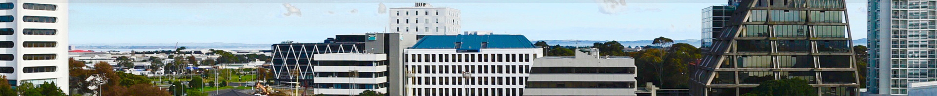
Manukau: Heart of the South ‘Powered by Business Manukau’ Associate Membership
Thank you for considering joining the Manukau Business Association Inc. (Business Manukau) as an Associate Member.
Manukau: Heart of the South ‘ powered by Business Manukau’ (BM) is the Heart of the South, vibrant, diverse, and a fast-growing suburb in South Auckland.
Our Associate membership will provide you with the opportunity to engage with our local business community.
Costs:
The Associate Membership package will cost (pro-rated from 1 July each year):
- $200 (plus GST) for individual members/sole traders working from home or not-for-profit organisations operating in the wider Auckland area (outside Business Manukau’s geographical boundaries).
- $300 (plus GST) for a business operating from the wider Auckland area (outside Business Manukau’s geographical boundaries).
Please note – Associate membership places are limited and are to be authorised by the BM General Manager.
Benefits of an Associate Membership will include:
- Listing on our website Business Directory
- *Free (or heavily subsidised) business networking events, at least six events planned annually including the business networking breakfasts with special guest speakers, after-5 networking, crime prevention workshops and more.
- Sponsorship opportunities available for Business Manukau events.
- Regular email updates about what is happening in and around the Manukau Business District.
*Associate membership allows up to two attendees per event.
More Information:
If you would like more information about Associate Membership, please contact Audrey Williams, General Manager manager@businessmanukau.co.nz

Associate Membership Application Form
Contact Details
Business Name:

Street Address: Postcode:

Postal Address (if different from above):

Phone:

Email: Website:

Facebook: Instagram:

Business Category:

Number of employees:

Contact Name:

Email: Phone:

Position: (e.g. Owner, CEO, MD, GM):

Second Contact:
Name:

Email: Phone:

Position:

Signed: Date:

By signing this form and paying the subscription fee, you are agreeing to become a member of Business Manukau & receiving information as noted above. No contact information collected will be distributed to any other party.**Please return this completed form to Janene Pryce, Comms and Events Manager on info@businessmanukau.co.nz
**Please note - Associate membership places are limited and are to be authorised by the BM General Manager.

